Object Oriented Languages and Environments

CS 474 Homework 1

Tathagata Ganguly

|  |  |
| --- | --- |
| 1 | Java Mission Control |
| 2 | jcmd utility |
| 3 | Java VisualVM |
| 4 | JConsole utility |
| 5 | jmap utility |
| 6 | jps utility |
| 7 | visualgc utility |

**1)Java Mission Control**

Step 1: Run JMC in your terminal

Step 2:Inside the project in Intellij, RUN -> EDIT CONFIGURATIONS ->  
VM OPTIONS : -XX:+UnlockCommercialFeatures -XX:+FlightRecorder -XX:StartFlightRecording=duration=2m,filename= File_name (D:\OOLE\Algo_bitCount_Recording.jfr for me)

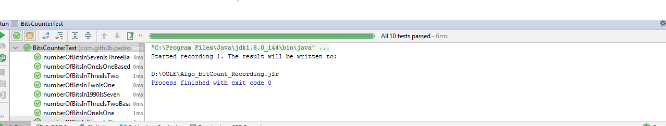

The recording can be viewed at JMC.

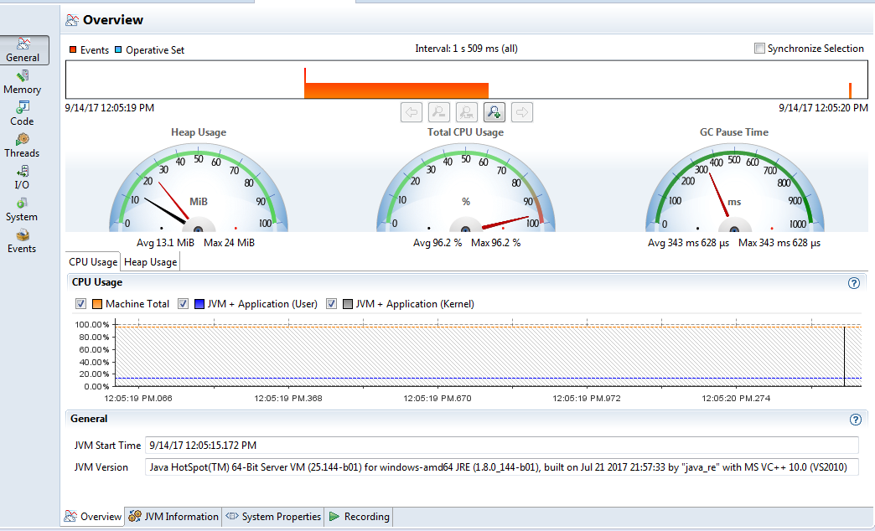

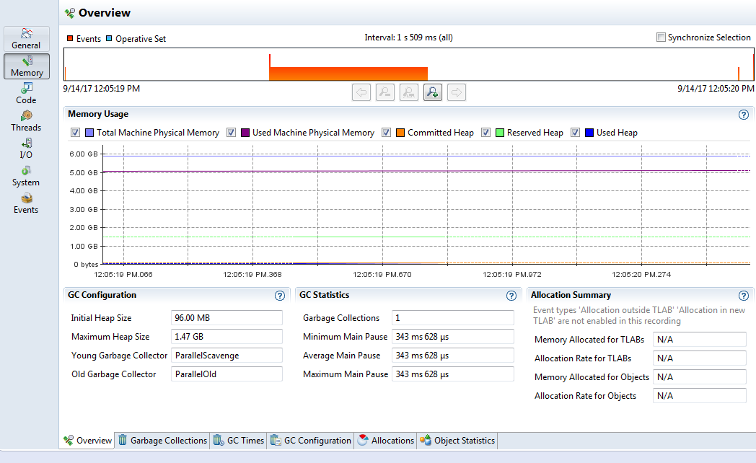

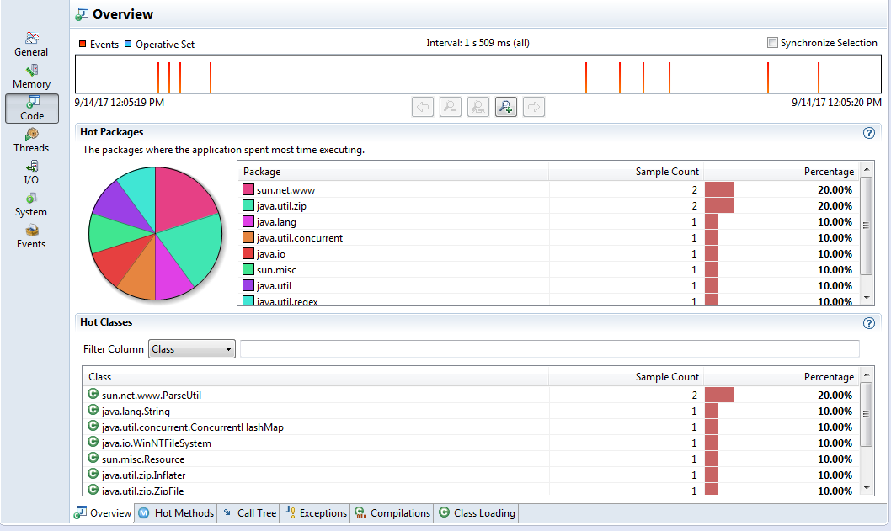

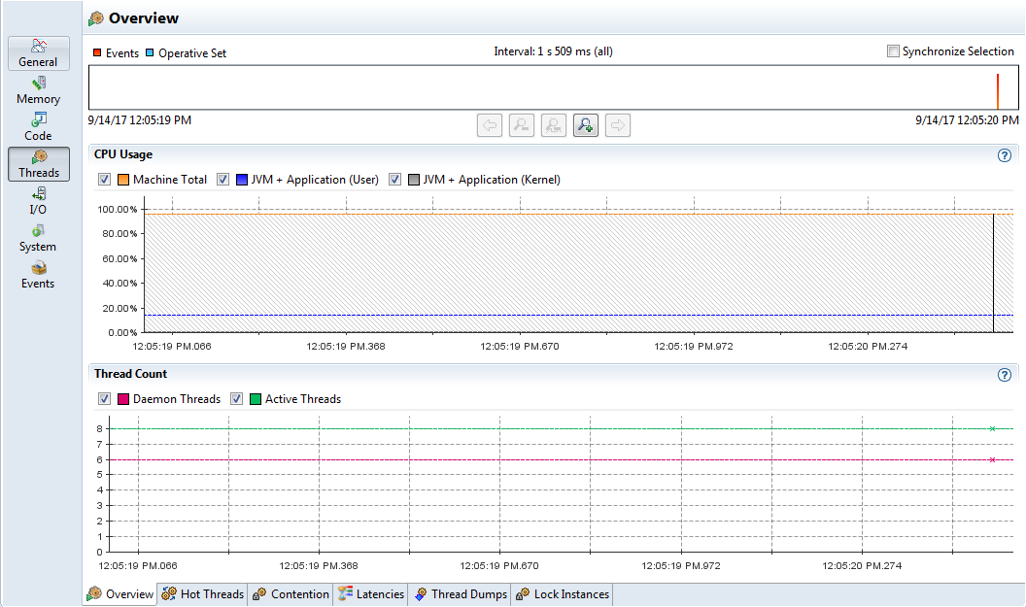

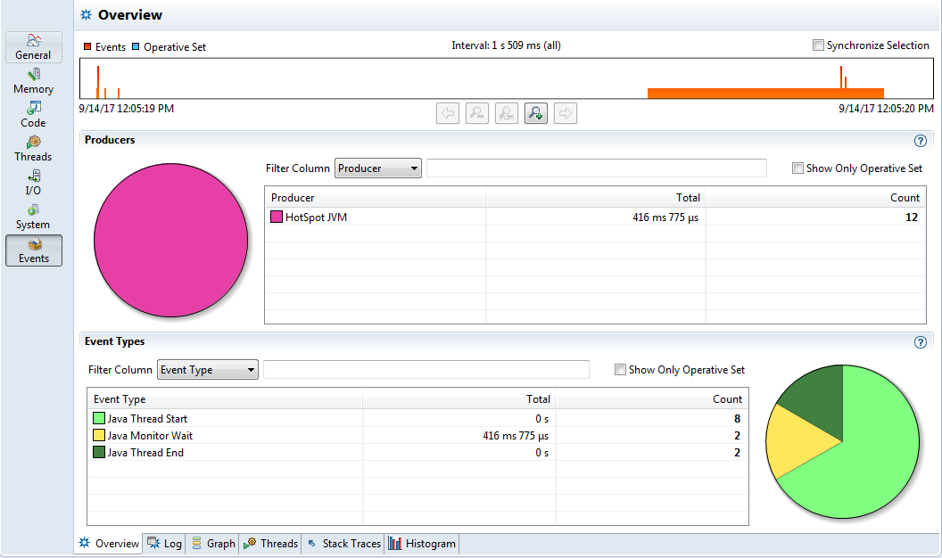

**2 ) jcmd Utility**

i. Run 'jcmd' /'jcmd -l'in the terminal

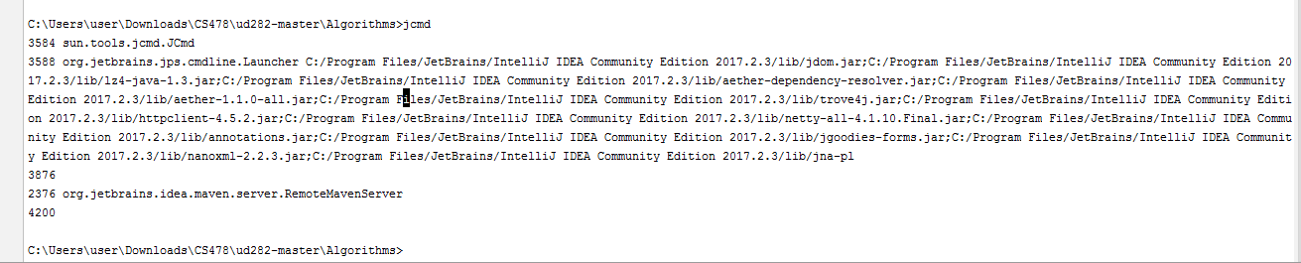

ii.Run 'jcmd -h' for help

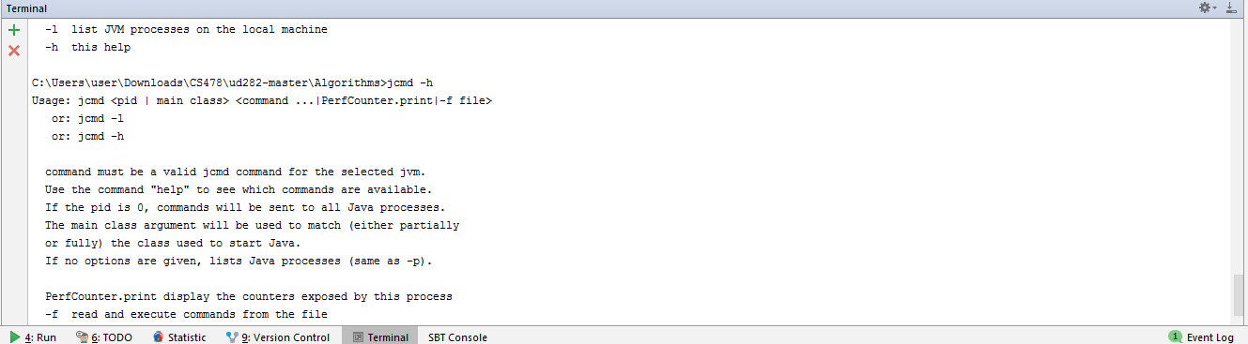

iii.Run 'jcmd <pid> VM.system_properties' to view all the system properties of VM

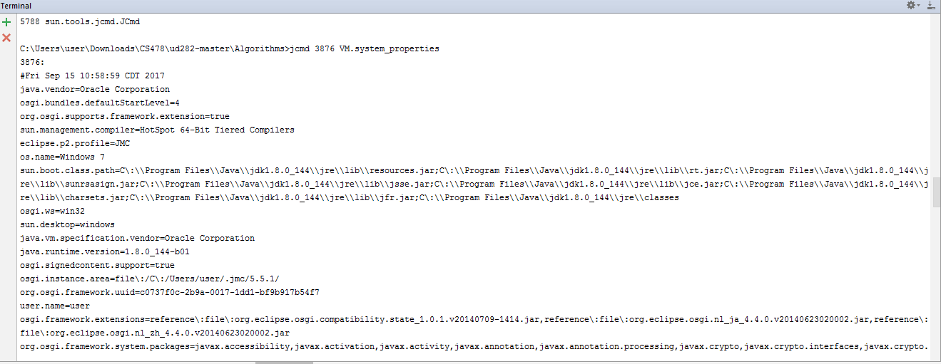

iv. Run 'jcmd <pid> VM.version' to view all the version of VM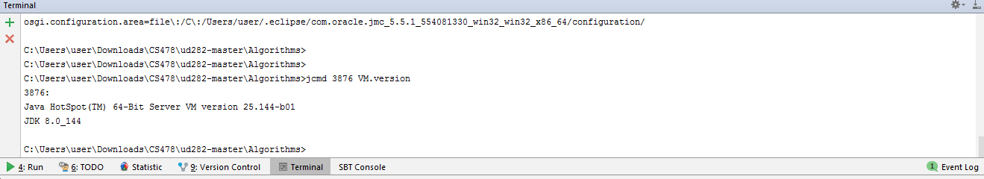

iv. Run 'jcmd <pid> VM.uptime' to view all the uptime of VM

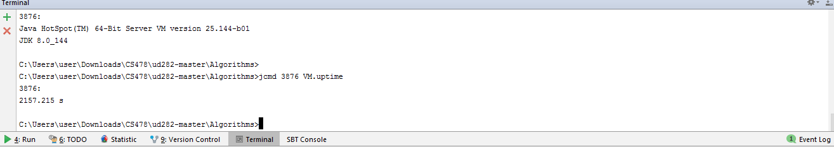

v. Run 'jcmd<pid> GC class_histogram to create a class histogram

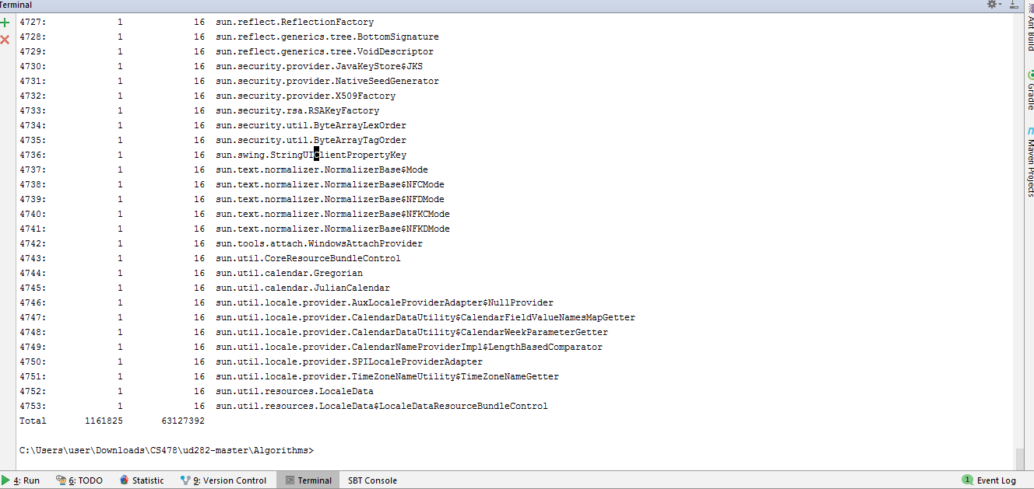

vi. Run 'jcmd <pid> GC.heap_dump filename=Myheapdump to create a heap dump file.

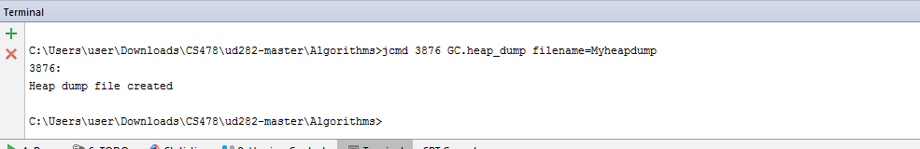

vii.Run jcmd <process id/main class> GC.class_histogram filename=Myheaphistogram to create a heap histogram file.

viii. Run jcmd <pid> Thread.print to print all threads with stack traces

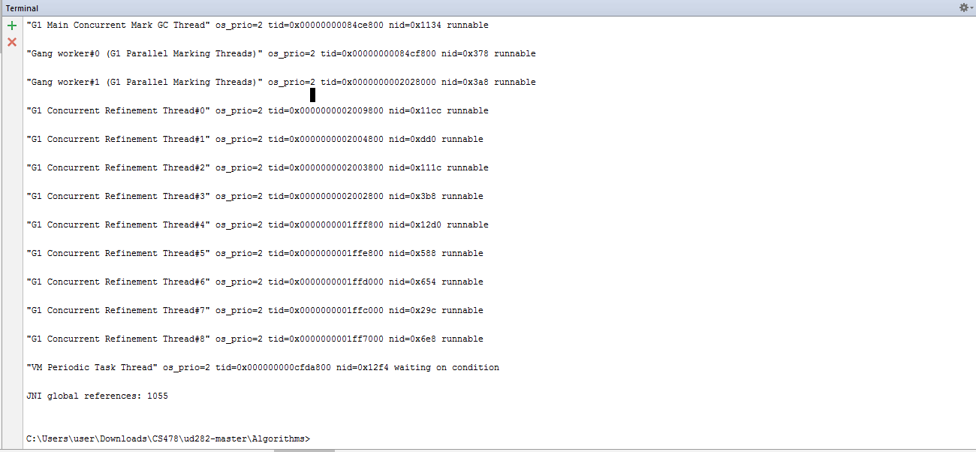

ix. Run jcmd <pid> VM.flags to print all the flags used for the VM

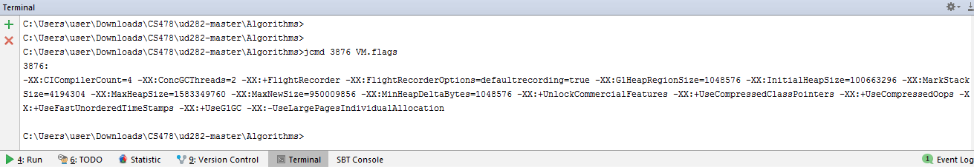

**3)JAVA VISUAL VM**

Step 1: Open settings ->Install Visual VM plugin and restart Intellij

Step 2: Open settings-> Open Visual VM launcher ->Run program

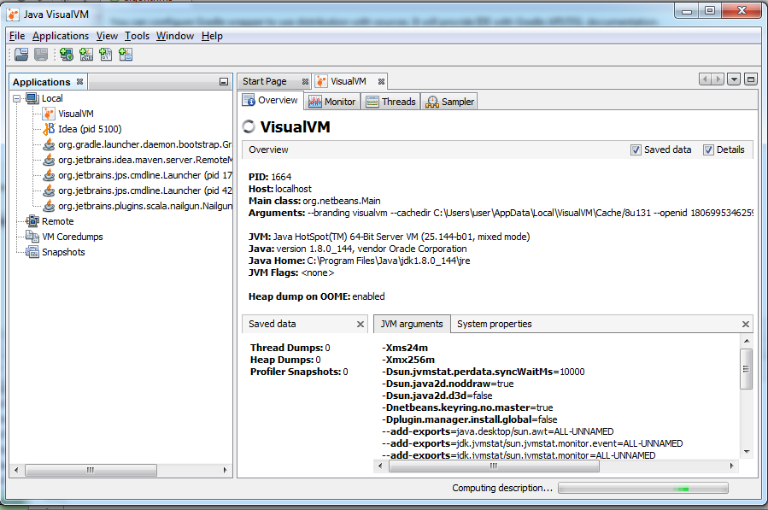**VISUAL VM OVERVIEW**

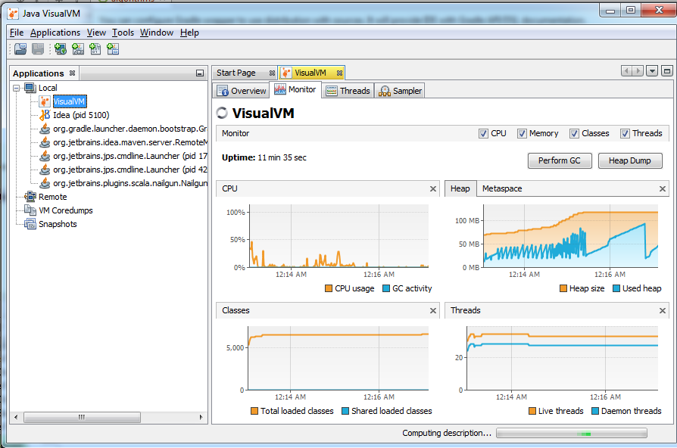

**MONITOR**

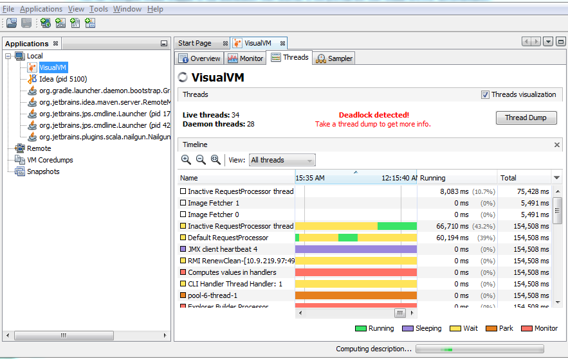**THREADS**

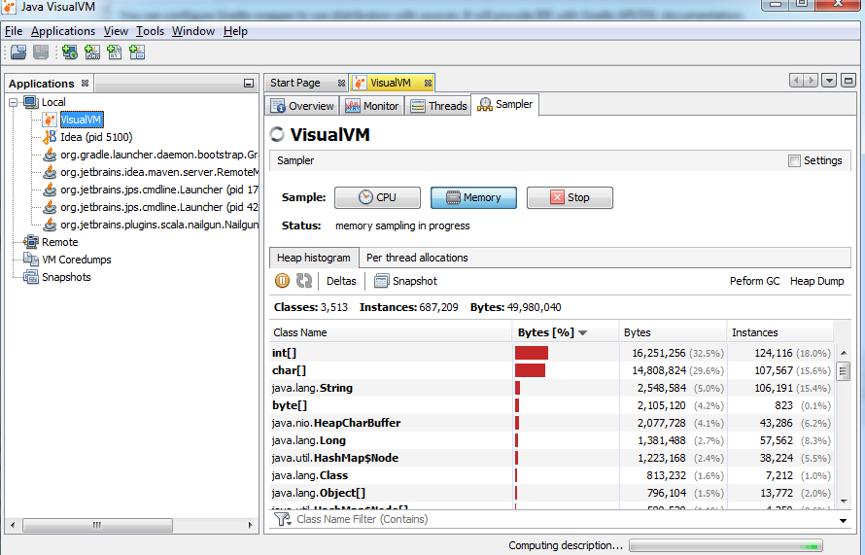**SAMPLER MEMORY**

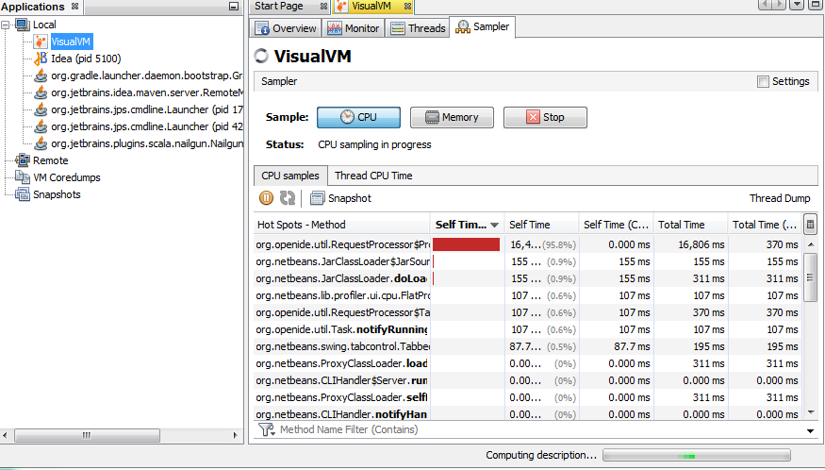**SAMPLER CPU**

**4)JConsole Utility**

Run 'JConsole in the terminal

Java Monitoring and Management console pops up

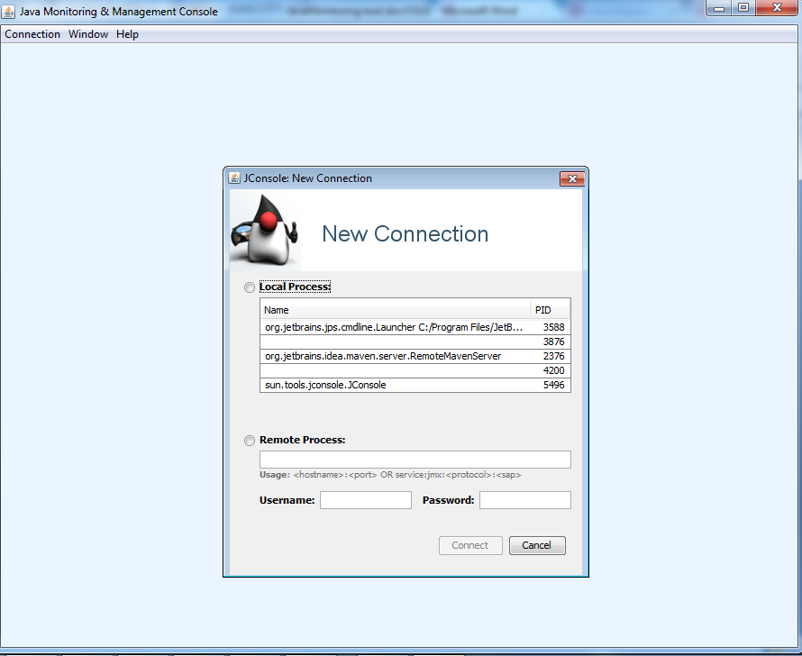

Choose any free PID to connect

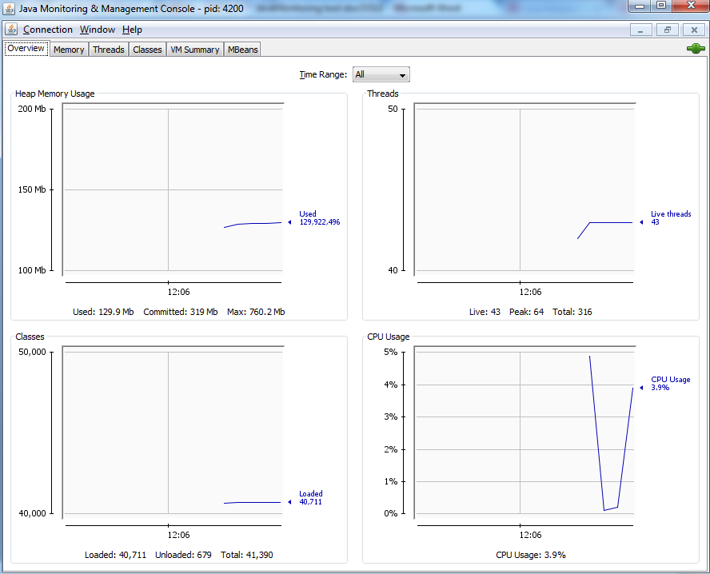

**Overview**

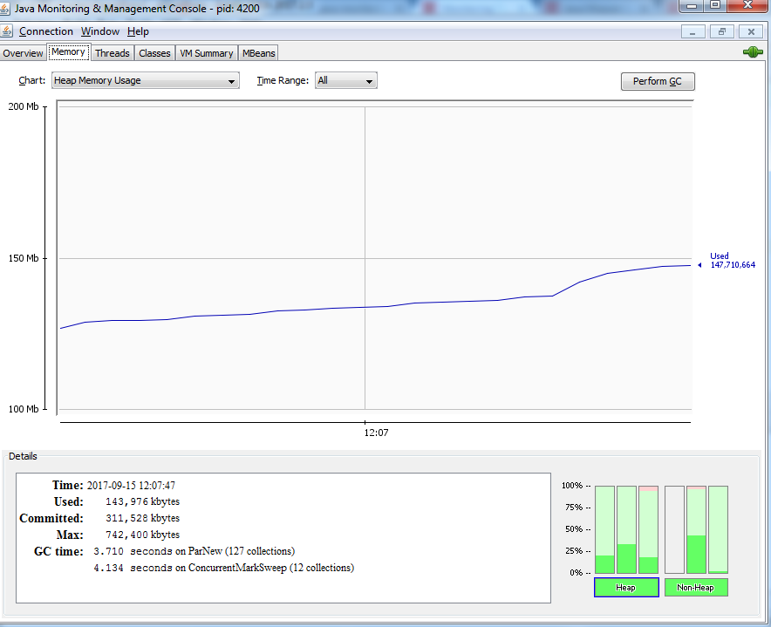

**MEMORY**

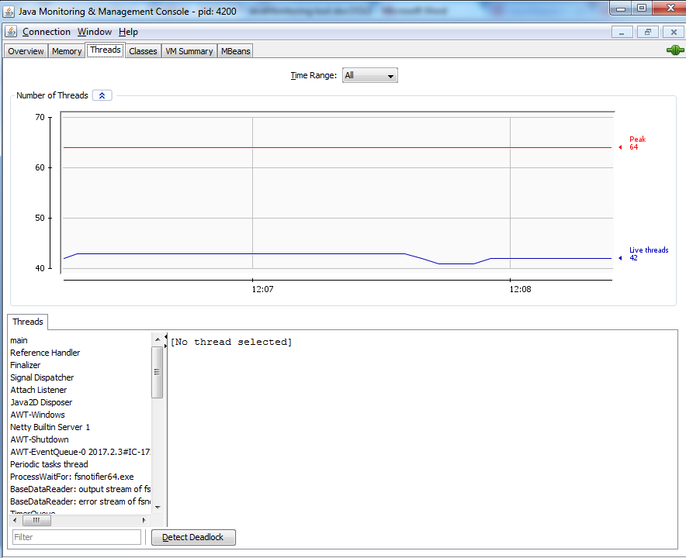

**THREADS**

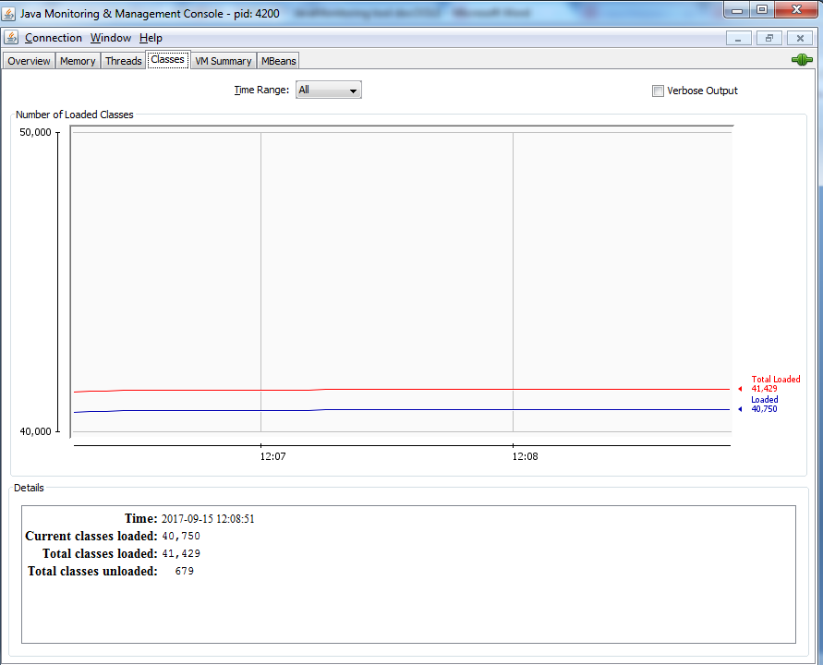

**CLASSES**

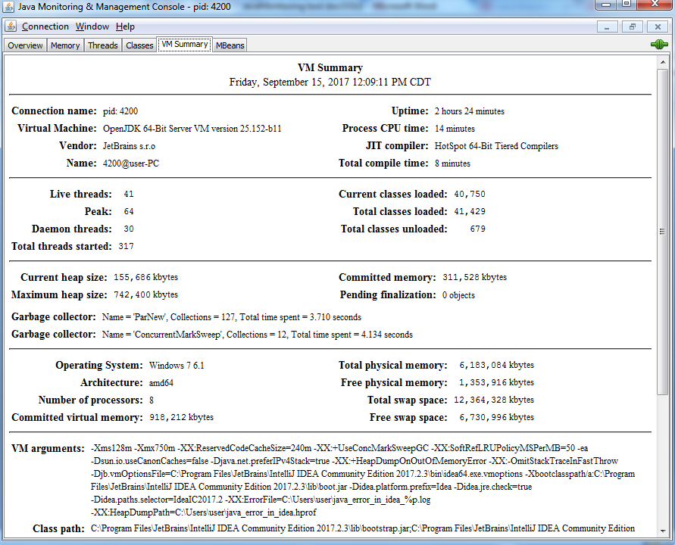

**VM SUMMARY**

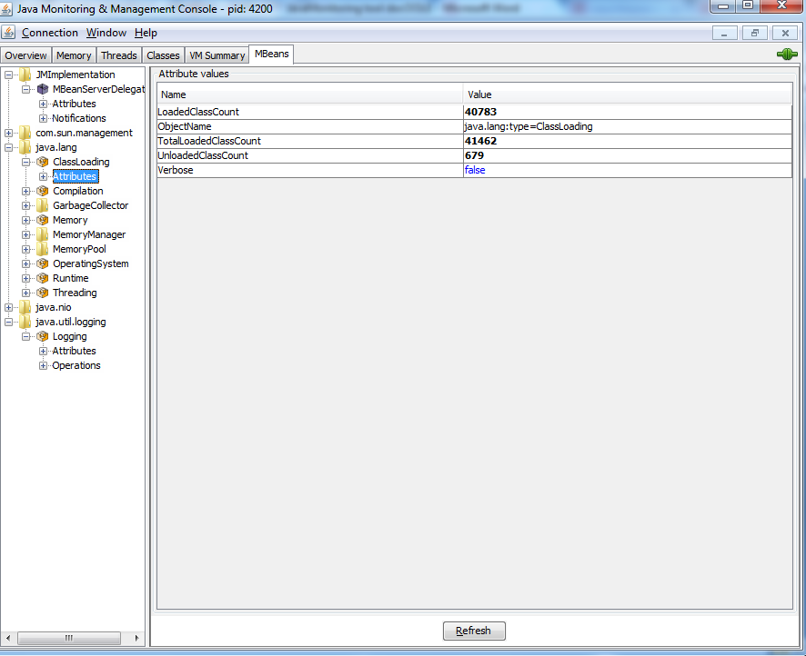

**You can also use Mbeans for further analysing the data.**

**5)jmap Utility**

jmap -histo <pid> to create a heap histogram

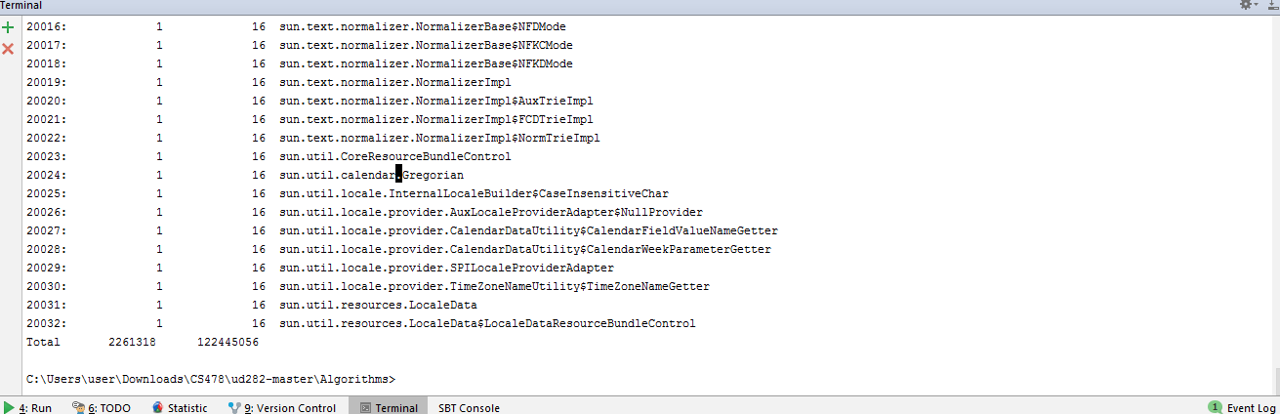

jmap -dump:file=<file> <pid> to create a heap dump

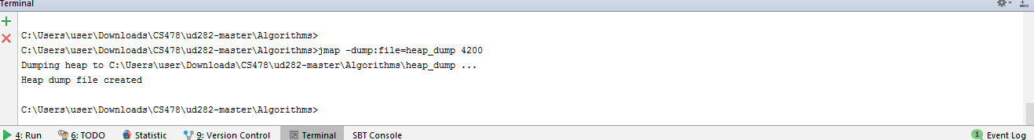

**6)jps Utility**

Run 'jps' in terminal to  list the instrumented Java HotSpot VMs on the target system.

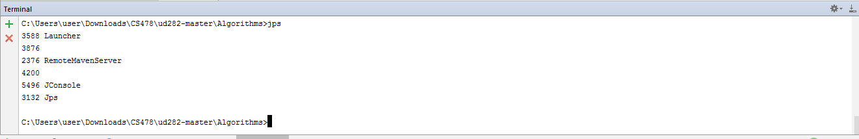

**7)Visual GC**

Run Java VisualVM, and click "Tools > Plugins"

Click the "Available Plugins" tab and install "Visual GC" from the list

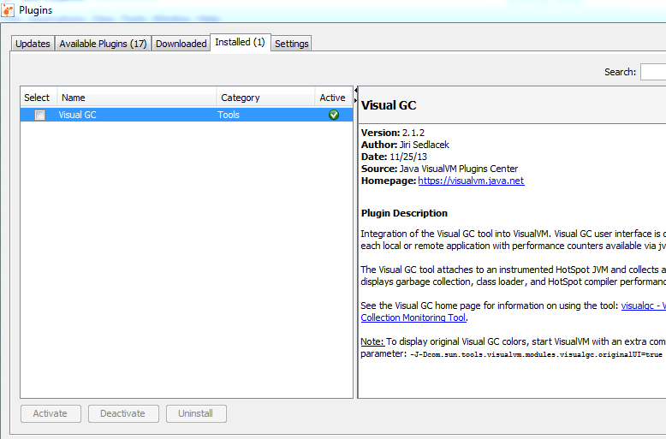

Run the program and use visualVM to monitor it.

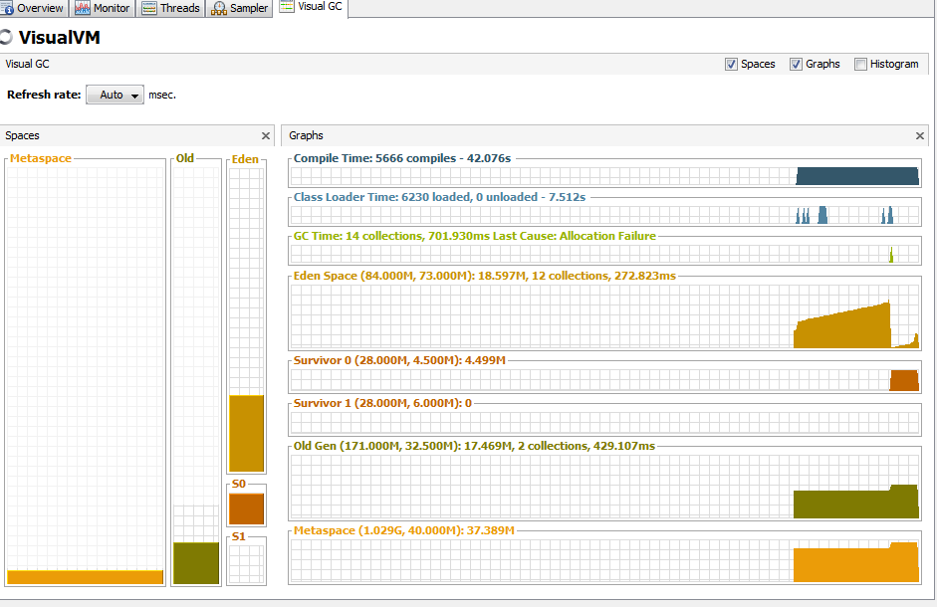

Citations

https://docs.oracle.com/javase/8/docs/technotes/guides/troubleshoot/tooldescr006.html#BABEHABG

https://www.javacodegeeks.com/2016/03/jcmd-one-jdk-command-line-toolrule.html

http://www.herongyang.com/Java-Tools/jvisualvm-Install-Visual-GC-Plugin.html